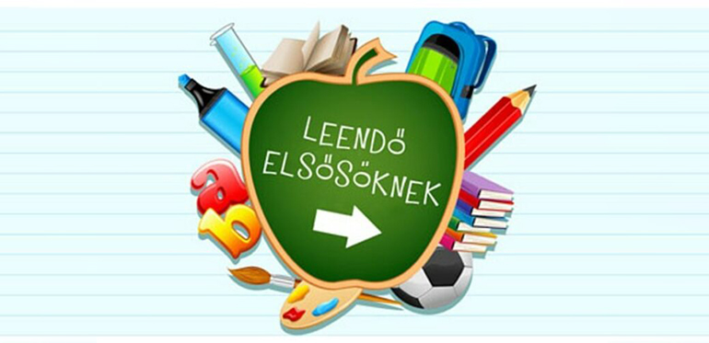
1.a Szűcsné Bukovszky Julianna |  |  |  | 1.b Baloghné Oláh Katalin
 |  |  |  | Sándor Judit
73721961948 |  |  |  | 74130099243
74027254168 |  |  |  | 73940698340
74146838153 |  |  |  | 73906610890
73718088216 |  |  |  | 74140061947
73951407746 |  |  |  | 73718055761
73644735874 |  |  |  | 73658715612
74053851751 |  |  |  | 73947812394
73939817313 |  |  |  | 73930412261
74127103774 |  |  |  | 74134194231
74139337829 |  |  |  | 73960200707
73783877308 |  |  |  | 73557267481
73930032979 |  |  |  | 73607637809
73561975352 |  |  |  | 74081511911
74367635695 |  |  |  | 74136536364
74141512980 |  |  |  | 74138681506

Szeretettel várunk minden
1. osztályos gyermeket!

